**National University of Computer & Emerging Sciences**

**Department of Computer Science**

**Database Systems**

**Assignment # 01**

**_____________________________________________________________________________**

**Instructions:**

|  |
| --- |
| 1. Assignment should be done on A4 sheets. 2. Scan your assignment and make a PDF document with the convention “**BSCS_5B_XXF-XXXX_A#1**”, also submit your hard form. 3. Plagiarism is strictly prohibited; assignment will be marked **zero** if plagiarized. 4. Late submission is not allowed. 5. **Evaluated out of 160 Marks.** |

1. Why would you choose a Database Management System (DBMS) over storing data in operating system files? Identify the key limitations of the file-based approach that a DBMS resolves. **(10 marks)**
2. How does the three-level architecture of a DBMS (external, conceptual, and internal levels) enhance the design of an online learning platform with courses, quizzes, and progress tracking? **(10 marks)**
3. Create a Three Schema Architecture for an online retail platform that includes product browsing, shopping cart management, and order processing. Specify the external schemas for customers, vendors, and system administrators, and explain how this architecture facilitates seamless user interactions. **(15 marks)**
4. Consider a scenario where you are designing a database for an online store. The database includes three entities: Products, Suppliers, and Customers. Each entity has its set of attributes. Attributes for each entity are given below: **(20 marks)**

**Products**:

* *ProductID*
* *SupplierID*
* *Name*
* *Description*
* *Price*
* *Quantity Available*

***Suppliers****:*

* *SupplierID*
* *Company Name*
* *Contact Name*
* *Email*
* *Phone Number*
* *Address*

***Customers****:*

* *CustomerID*
* *First Name*
* *Last Name*
* *Email*
* *Phone Number*
* *Address*

**Identify the types of keys for the given attributes and provide a justification for your answer.**

* + - *ProductID*
    - *SupplierID in Products*
    - *SupplierID in Suppliers*
    - *CustomerID*
    - *Email*
    - *Phone Number*
    - *ProductID and SupplierID*
    - *ProductID and CustomerID*
    - *CustomerID and Email*

Identify artificial (surrogate) keys in all tables and give a brief explanation. **(10 marks)**

1. An online restaurant management system is designed to streamline the ordering, delivery, and inventory management processes. The system involves entities such as **Orders, Customers,** and **Delivery Personnel**. Each order is uniquely identified by an **OrderID** and contains information about the items ordered, total cost, and delivery address. Customers have unique **CustomerIDs** and provide personal details like name, contact information, and delivery preferences. Delivery Personnel are assigned unique IDs and have information about their availability and delivery history.

Identify entities, state attributes for each entity, state primary keys, state relationships between entities and cardinalities, and draw an ER diagram for this scenario. **(25 marks)**

1. Convert the given ER diagram into relational database schema. Be certain to indicate primary keys and referential integrity constraints. **(30 marks)**

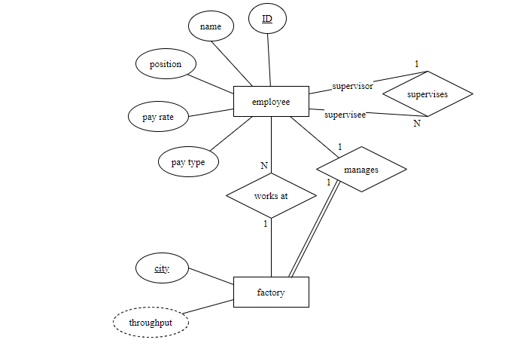

1. Refer to the ER diagram below to answer the following questions:

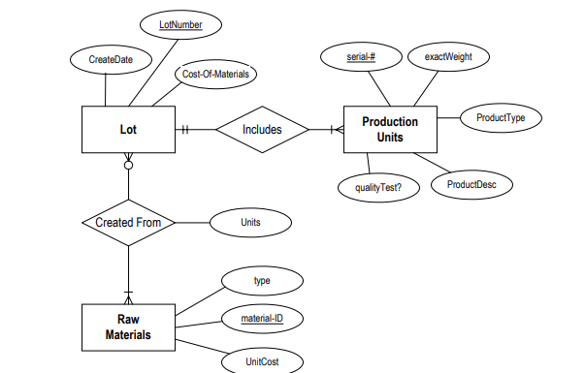

1. Identify an attribute in the above ER diagram that might represent a composite attribute, and explain why/how it might represent a composite attribute. **(2 marks)**
2. Identify an attribute in the ER diagram that could represent a derived attribute and explain why/how it might represent a derived attribute. **(2 marks)**
3. The ER diagram/relational database schema contains several instances of data redundancy. Identify one instance where a data redundancy issue exists**. (2 marks)**
4. The current ER diagram has the following relationship, “raw materials are used in 0 to many lots.” Explain, in the context of the manufacturing environment, how the meaning changed if the minimal cardinality is changed to “1” (i.e., the relationship becomes "raw materials are used in 1 to many lots.”) **(4 marks)**
5. The Country Bus Company manages multiple buses, each identified by several attributes: **registration number, engine number, vehicle ID, number of seats, capacity,** andwhether the bus is **single-decker or double-decker.** Each bus is assigned to a specific route, though some routes may have multiple buses assigned to them. A route is characterized by the following attributes: **route ID, name, and the average number of passengers per route**. Each route passes through several towns.Each town has a unique town **ID and name**. For each stage of the route, one or more drivers are assigned. A stage refers to the journey through some or all the towns on a route. The driver attributes include**: driver ID, name, address, contact number, driver license number,** and **years of experience**.Some towns have garages where buses are kept. The garage attributes are **garage ID, name, location, and capacity.** Each bus follows a schedule for departures and arrivals at different locations. The schedule includes: **bus ID, departure location, arrival location, departure time, and arrival time.**

**Draw an ER Diagram for the given scenario. (30 marks)**

**_____________________________________________________________________________**

**All the best! ☺**